**1.Modelo RF5_Indeg Apoio Levantamento diques cintura X All var**.

***Instrucciones modelo***: **test size = 0.31 ; rd_state = 9**

***Variables indep select to fit***:

variables = ['id', 'Indeg_RedeRisk_Cen','PC1_Distance_Pro',

    'Avg_Distancia_Dist_moranza','Degree_RedeTotFamil',

    '1_VarExp_Moranca','2_VarExp_Atri_Tabanca','OutDeg_IntimAmigos_', 'OutDeg_RedeRisk_Cen']

***Model performance (scores):***

Mean Squared Error: 0.9750

R^2 Score: 0.5062 (In Excel: R2 = 0.5538 ; y = 0.3963 X + 0.3928 )

**Model tot:**

Mean Squared Error (MSE): 0.4419

Root Mean Squared Error (RMSE): 0.6647

Mean Absolute Error (MAE): 0.3333

R^2 Score: 0.7167

Pearson Correlation: 0.8593

***Interactions***:

| **Interacción** | **Importancia** | **Dirección** |
| --- | --- | --- |
| 0 | (2_VarExp_Atri_Tabanca, OutDeg_IntimAmigos_) | 0.427430 | 0.480859 |
| 1 | (2_VarExp_Atri_Tabanca, OutDeg_RedeRisk_Cen) | 0.415562 | 0.467507 |
| 2 | (Avg_Distancia_Dist_moranza, 2_VarExp_Atri_Tab... | 0.407650 | 0.001155 |
| 3 | (Indeg_RedeRisk_Cen, 2_VarExp_Atri_Tabanca) | 0.405009 | 0.022230 |
| 4 | (Degree_RedeTotFamil, 2_VarExp_Atri_Tabanca) | 0.396763 | 0.017887 |
| 5 | (1_VarExp_Moranca, 2_VarExp_Atri_Tabanca) | 0.386942 | 0.002525 |
| 6 | (PC1_Distance_Pro, 2_VarExp_Atri_Tabanca) | 0.382284 | -0.001183 |
| 7 | (Degree_RedeTotFamil, OutDeg_RedeRisk_Cen) | 0.294841 | 0.030610 |
| 8 | (OutDeg_IntimAmigos_, OutDeg_RedeRisk_Cen) | 0.263086 | -0.023937 |
| 9 | (PC1_Distance_Pro, OutDeg_RedeRisk_Cen) | 0.258145 | -0.002266 |

***Key results****:*

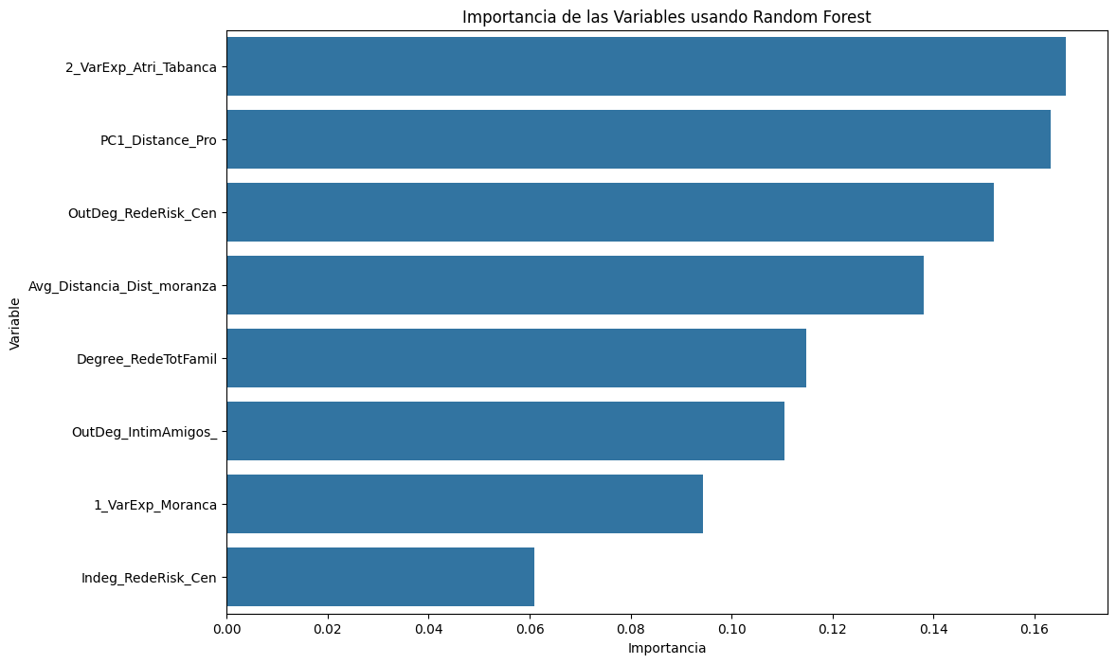

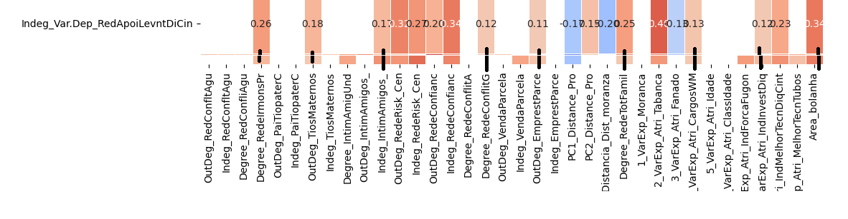

**2.Modelo RF5_Outdeg Apoio Levantamento diques cintura X All var**.

***Instrucciones modelo***: **test size = 0.22 ; rd_st: 9**

***Variables indep select to fit***:

variables = [ 'id', 'Indeg_IntimAmigos_', 'Indeg_RedeRisk_Cen',

    'Indeg_RedeConfianc', 'Avg_Distancia_Dist_moranza',

    'Degree_RedeTotFamil', '1_VarExp_Moranca', '2_VarExp_Atri_Tabanca',

'5_VarExp_Atri_Idade', '7_VarExp_Atri_IndForcaFugon',

'8_VarExp_Atri_IndInvestDiq', '9_VarExp_Atri_IndMelhorTecnDiqCint',

'Area_bolanha','OutDeg_RedeRisk_Cen']

***Model performance (scores):***

Mean Squared Error: 0.4828

R^2 Score: 0.7192 (on excel: **R2= 0.7355 ; Y = 0.6736 X + 0.166** )

**Model tot:**

Mean Squared Error (MSE):0.2248

Root Mean Squared Error (RMSE):0.4741

Mean Absolute Error (MAE): 0.1938

R^2 Score: 0.8326

Pearson Correlation: 0.9209

***Interactions***:

| **Interacción** | **Importancia** | **Dirección** |
| --- | --- | --- |
| 0 | (Indeg_RedeConfianc, OutDeg_RedeRisk_Cen) | 0.421375 | 0.131552 |
| 1 | (Indeg_RedeConfianc, 9_VarExp_Atri_IndMelhorTe... | 0.408920 | 0.117128 |
| 2 | (Indeg_IntimAmigos_, Indeg_RedeConfianc) | 0.406459 | 0.051086 |
| 3 | (Indeg_IntimAmigos_, 9_VarExp_Atri_IndMelhorTe... | 0.393938 | 0.058158 |
| 4 | (Indeg_RedeConfianc, Degree_RedeTotFamil) | 0.393206 | 0.135547 |
| 5 | (Indeg_RedeConfianc, 5_VarExp_Atri_Idade) | 0.390944 | 0.132798 |
| 6 | (8_VarExp_Atri_IndInvestDiq, 9_VarExp_Atri_Ind... | 0.390466 | -0.028168 |
| 7 | (Indeg_RedeConfianc, 8_VarExp_Atri_IndInvestDiq) | 0.388226 | 0.132082 |
| 8 | (Indeg_RedeConfianc, Avg_Distancia_Dist_moranza) | 0.387991 | 0.130206 |
| 9 | (Indeg_RedeConfianc, 2_VarExp_Atri_Tabanca) | 0.386023 | 0.131223 |

***Key results****:*



